[Your Company Name & Logo Here]
Toolbox Talk
Mental Health & Workplace Safety

For many years it was considered taboo to talk about mental health at work and other public places. Fortunately, the stigma over talking about mental health is changing.

Two mental health conditions that are most frequently observed in the workplace are depression and anxiety.

It is important to treat mental health like we do physical health. We do not blame individuals for getting sick so we should be accepting of individuals who may be struggling with mental health issues.

It is important to treat all employees with respect. The company’s Safety 24/7 culture is intended to build a caring culture where we look after one another.

Checking in with your crewmates to let them know you care demonstrates respect and concern for their wellbeing. Taking time to listen or being patient can go a long way to making people feel respected and cared for.

Mental health is a personal issue, a family issue, a community issue, and a society issue. This is why mental health is an important part of our Safety 24/7 culture.

Mental health is increasingly being integrated into safety, health and wellness programs:

-- This topic is addressed in our quarterly employee newsletter.
-- Posters have been displayed prominently in all major work areas where employees gather.
-- Wallet cards have been distributed for the Crisis Text Line as well as the National Suicide Prevention
Lifeline.
-- Mental health has been a topic addressed at the annual leadership conference.
-- The Risk/Safety and Human Resources Departments have compiled a resource directory for various
mental health resources and organizations.

We have been encouraging our union partners to launch Member Assistance Programs where union members and their families can receive mental health counseling and behavioral health services care that is aligned with the health insurance plans offered by the unions.

We want to share a great resource that is free, confidential and available on a 24/7 basis it is called Crisis Text Line. This service is available for people of all ages who are looking for help.

To contact Crisis Text Line, all you do is text “HELLO” to 741741. You will quickly receive a confirmation that your message is being routed to a counselor.

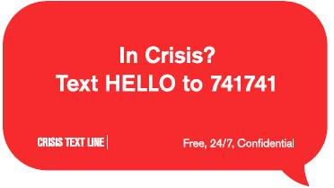

© Lakeside Industries, Risk Management & Safety Department
EMPLOYEE # PRINT NAME: SIGNATURE:

