CRAIG RUPPERT INDUCTED INTO THE WASHINGTON BUSINESS HALL OF FAME
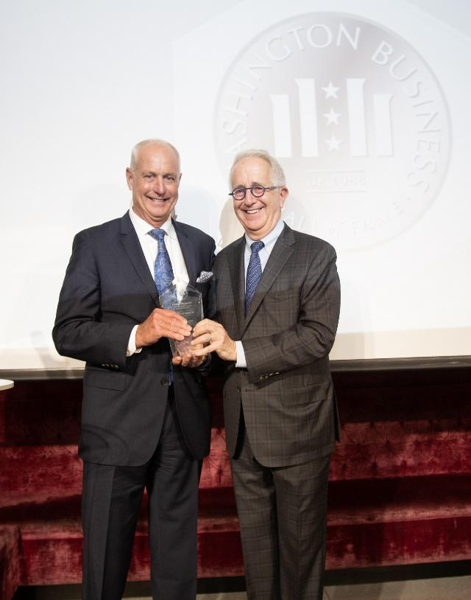
LAYTONSVILLE, MD (December 17, 2021) – On December 1, 2021, Craig Ruppert, Founder and Chief Executive of Ruppert Companies, was among the 2021 Laureate class inducted into the Washington Business Hall of Fame by Junior Achievement of Greater Washington.
This year’s class of distinguished honorees was celebrated for their professional and philanthropic contributions to the quality of life in Greater Washington through the private sector economy. Craig was inducted alongside three additional 2021 Hall of Fame Laureates:
- Virginia Ali – Owner, Ben’s Chili Bowl
- Russ Ramsey – Chairman and CEO, Ramsey Asset Management
- Deborah Ratner-Salzberg – Principal, Uplands Real Estate Partners
The 2021 Hall of Fame was a hybrid experience dedicated to connecting the best in business to inspire the next in business through a full day of programming. The virtual experience included a Town Hall moderated by Leon Harris of NBC4, a series of master class presentations led by business and community leaders, and a virtual Laureate Induction Ceremony. VIP attendees gathered to personally congratulate the 2021 Laureates at a Laureate Celebration Reception at La Vie located at the District Wharf. Over $1.25 million was raised to support Junior Achievement’s work to prepare young people to be future-ready.
“I am very honored to be sharing this recognition with Virginia, Debby and Russ—who each in their own way have helped shape their respective industries—and am grateful to be following in the footsteps of past laureates who have made their own indelible mark on this region’s business community,” said Ruppert. “Most of all, I want to commend Junior Achievement and their volunteers for all they’re doing to inspire students and prepare them with the tools and experiences they need for a fulfilling and productive future.”
Since its founding in 1988, more than 125 Laureates have been inducted into the Washington Business Hall of Fame. Laureates are selected for consistently demonstrating excellence in business, visionary leadership, and an ongoing commitment to community engagement. Through their commitment to the Washington D.C. community, this year’s honorees demonstrate these attributes in every facet of their lives.
Chaired by Jermaine Johnson, Regional President at PNC Bank, the Hall of Fame was presented by Capital One, Carlyle, and PNC Bank, and supported by business partners, the Greater Washington Board of Trade and the Washington Business Journal, as well as 150-plus business and community partners.
For more information about the Washington Business Hall of Fame, visit washingtonbusinesshalloffame.org.
###
About Ruppert Companies:
Ruppert Companies is a family and employee-owned business comprised of Ruppert Landscape (established in 1976), a commercial landscape construction and management contractor; Ruppert Nurseries (established in 1990), a wholesale tree grower; and Ruppert Properties (established in 1999), which owns, constructs and manages industrial properties in the Frederick, MD area. By being part of a team, our companies gain exposure to other industries and are able to benchmark best practices, which makes us more valuable to our customers and our employees. Ruppert Companies has a long-standing tradition of growing its team and giving back to the community. To learn more, visit www.ruppertcompanies.com.
About Junior Achievement of Greater Washington:
Junior Achievement of Greater Washington is a non-profit organization that is changing the game for our region’s youth with relevant, experiential education in financial literacy, work readiness and entrepreneurship. We bring together school systems, business leaders and trained mentor volunteers to provide equal access to the tools, people and experiences all youth need to be 100% prepared for real life in the real world. That means students gain what matters most: control over their own lives, futures and careers. To learn more, visit myJA.org.
Photo caption: Craig Ruppert, Chief Executive of Ruppert Companies, with Alex Orfinger, Market President and Publisher of the Washington Business Journal, at the Junior Achievement of Greater Washington Business Hall of Fame induction ceremony on December 1st, 2021.

